Abstract
A business is a non-equilibrium leverage machine. It accumulates optionality through configuration (Production Capability), releases that optionality into the environment through activation (Distribution Velocity), and retains a fraction of realized output for reinvestment (Resource Efficiency). These functions correspond to the accumulation, release, and dissipation control observed in all productive systems. Profit and growth emerge not from any single function, but from disciplined allocation across them via a control mechanism (the Dynamic Fulcrum) that governs when accumulated potential is released, retained, or redirected under constraint.
A Solution To Profitability And Non-Extinction
Throughout history, when a single person or group is more productive relative to competitors, that person or group has better odds of surviving relative to those competitors. In the limit, the more productive group extinguishes or at least tries to extinguish all competitors.
Entrepreneurs and investors especially need to understand and practice productivity at scale since they use leverage.
To fully harness productivity, a general understanding of it is required which requires a coordinate system (or reference frame) in which to describe cause-effect relationships that map to the real world, and a model that makes use of those relationships in a productive way.
Concept: The solution to productivity is the exploitation of a technology through the efficient assembly of a dynamic sales letter.
A General Understanding Of A Dynamic Sales Letter: A Solution To Capital Efficiency (Concept Design)
Defining A Coordinate System
Assumption:
A business is a machine that does productivity. Productivity is the rate of output > unit of input. A business is a machine that does productivity or duplicates a productive event using some technology/ies. (where the unit is capital or Joules (where Joules can be exchanged for capital through any nearest exchange)).
First we define a time-dependent business function based on current discounted future cash flow techniques.
The intrinsic value of a business at time, t, or 𝐼(𝑡) can be modeled by:
(1) 𝐼(𝑡) = 𝐸𝑛𝑡𝑒𝑟𝑝𝑟𝑖𝑠𝑒 𝑉𝑎𝑙𝑢𝑒(𝑡) + 𝐴𝑠𝑠𝑒𝑡𝑠(𝑡) - 𝐿𝑖𝑎𝑏𝑖𝑙𝑖𝑡𝑖𝑒𝑠(𝑡)
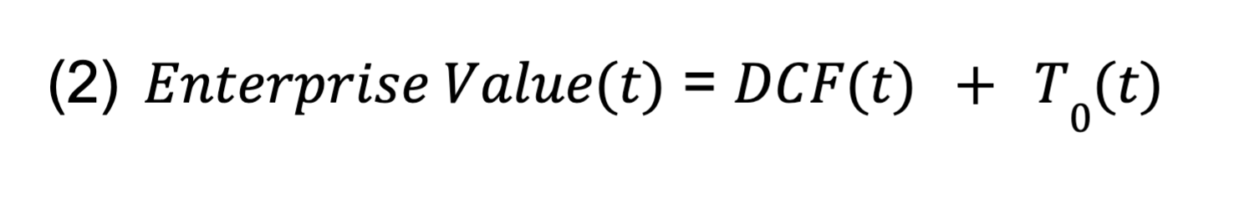
Where

Where 𝐷𝐶𝐹(𝑡) is the present value of the future cash flows up until a projection period (usually 5 years in most models):
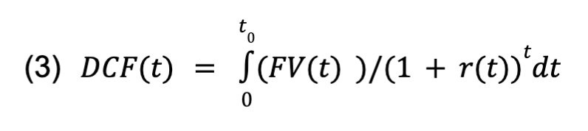
Where 𝐹𝑉(𝑡)is the levered free cash flow produced by the assets:
Where 𝑡₀ is the time at which the projection period ends. Where the projection period is the maximum time an investor feels comfortable projecting the cash flows based on his/her information at hand.
Where 𝑟(𝑡) is the dynamic discount rate that represents the rate of return an investor is forgoing to participate in the company, and is usually around 9% or whatever the average rate of return the S and P 500 is spitting out or the local inflation rate.
Where 𝑇₀(𝑡) is the terminal value - the present value of the approximation of the future cash flows accumulated after the projection period, 𝑡0 and in perpetuity, approximated by:
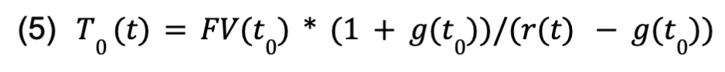
Where 𝑔(𝑡₀) is the terminal growth rate defined at the end of the projection period and is usually defined as the long term rate of inflation rate at 𝑡0, or proposed GDP growth rate local to the investors valuing the entity at time, 𝑡0.
Where, 𝐴𝑠𝑠𝑒𝑡𝑠(𝑡) are assets at the time of valuation, 𝐿𝑖𝑎𝑏𝑖𝑙𝑖𝑡𝑖𝑒𝑠(𝑡) are liabilities at the time of valuation, 𝐶𝑎𝑝𝑒𝑥(𝑡) is capital expenses at the time of valuation, 𝐼𝑛𝑡𝑒𝑟𝑒𝑠𝑡(𝑡) is the interest rate at time of valuation, and 𝑡𝑎𝑥𝑒𝑠(𝑡) are taxes at the time of valuation. These are all time-dependent - which means they can change as we go through time (they are not static).
The Resource Function, 𝑅(𝑡)
We define an input resource function, 𝑅(𝑡) to be a function of time, input capital (human and financial of operators), and technology exploitable of the operators who operate 𝐼(𝑡):
𝑅(𝑡, 𝑡𝑒𝑐h(𝑡), 𝐶𝑎𝑝𝑖𝑡𝑎𝑙)
Operator Function, 𝑂(𝑡)
We define an Operator function, 𝑂(𝑡) to be a function that represents the use of resources through activities by the operators.
Operators operate on resources: 𝑂(𝑡, 𝑅(𝑡)) to do things and operate 𝐼(𝑡).

Bounds Of 𝐼(𝑡)
𝐼(𝑡) is bound by its operator’s activities, defined with 𝑂(𝑡), and resources at time, 𝑡, 𝑅(𝑡). The better the operators apply resources, the more value they create.
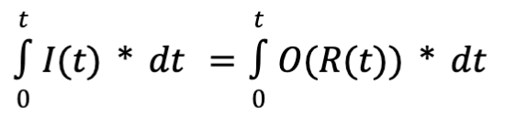
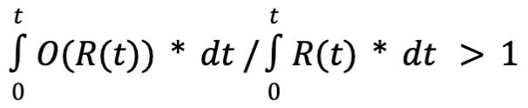
Measuring Return
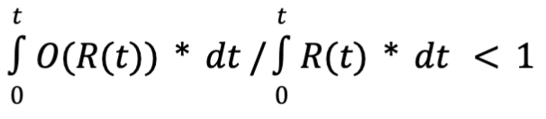
If operators get a higher output than what they input, then:
If operators get a lower output than what they input, then:

Units Of 𝐼(𝑡) - Energy Conservation
The units of 𝐼(𝑡), 𝑅(𝑡), 𝑂(𝑡),𝐶𝑎𝑝𝑖𝑡𝑎𝑙, 𝑡𝑒𝑐h(𝑡) are Joules, the unit of energy.
Intuitively, operators apply energy through calories and capital over time to rearrange physical things/mass by exploiting technology/ies. In a closed system where both the operators and the subjects on which they operate exist, energy is conserved.
Capital can be expressed in Joules through any energy exchange (like a gas pump), and fitness (the unit of benefit defined by biology or Hamilton’s Rule) can be expressed in Joules through a conversion that converts replication potential to calories (I’ll leave to you).
Intuitively, technology is the result of some operator/s (or technologist) applying energy at some point in time to mass over time to determine cause-effect ish relationships (loose definition of science).
𝑡𝑒𝑐h(𝑡) = 𝑅𝑒𝑠𝑜𝑢𝑟𝑐𝑒𝑠𝑇𝑜𝑀𝑎𝑘𝑒𝑇𝑒𝑐h(𝑡, 𝑚𝑎𝑠𝑠(𝑡), 𝑡𝑒𝑐h𝐶𝑎𝑝𝑖𝑡𝑎𝑙(𝑡))
Where 𝑚𝑎𝑠𝑠(𝑡) is the stuff the technologist rearranged and 𝑡𝑒𝑐h𝐶𝑎𝑝𝑖𝑡𝑎𝑙(𝑡) is the energy required to do the rearrangement.

Components Of 𝐼(𝑡)
Practically, 𝐼(𝑡) “operates” on a set of customers, to provide a benefit or a transformation to that customer set, for a price one in the set exchanges for the benefit that is delivered through a mechanism/s.
A person in the customer set learns of the mechanism, its price, and takes part in the transaction through some conduit (the distribution channel).
We can model it using:
𝐼(𝑡) = 𝐼(𝑁(𝑡), 𝑇(𝑡), 𝑃(𝑡), 𝑀(𝑡), 𝐴(𝑡))
Where 𝑁(𝑡) is the niche vector that represents a single person or a set of similar people in a market segment at a point in time.
Its attributes include: size of market, location, behaviors, capital levels, forces acted on them, genes, and memes imprinted (beliefs). These attributes are all time-dependent (hopefully not genes, but you never know :)).
𝑇(𝑡) is the transformation or benefit vector that represents a promise (or potential benefit) made to the niche, 𝑁(𝑡). We can define a problem as the absence of a benefit, and the absence of a problem to be a benefit in the niche’s reference frame. It’s time-dependent because the needs, expectations, and problems of the niche, 𝑁(𝑡) change with time and environment. We can define a benefit to be a change of fitness, defined by evolutionary biology relative to the niche due to use of a mechanism through 𝐼(𝑡). It can be positive or negative. Abstractly, the awareness of 𝑇(𝑡) by 𝑁(𝑡) causes intrigue and demand*
𝑃(𝑡) is a vector that represents the price the customer set or segment, 𝑁(𝑡) is willing to pay to achieve the benefit,𝑇(𝑡) through the mechanism, 𝑀(𝑡) ( where M is defined below). It depends on the transformation vector, T(t) which also depends on the niche's ability to pay and/or its resource levels. It’s measured in dollars or whatever currency the system uses. It’s also time-dependent (meaning the price relative to a customer set can change as we go through time). The price is subject to the value of the currency in which it is expressed.
𝑀(𝑡) is a vector that represents the mechanism with respect to time and it represents the tangible or intangible thing or set of things that deliver on the benefit, 𝑇(𝑡) for the price, 𝑃(𝑡), all relative to the niche, 𝑁(𝑡) assembled by operators. Its attributes include: Technology that is exploited by the operator to deliver the benefit, 𝑇(𝑡), 𝑡𝑒𝑐h(𝑡)(which is defined in the resource function), the costs required to exploit that technology, and the costs required to deliver the mechanism in physical or digital space to a customer in the set, 𝑁(𝑡). These attributes are all time-dependent, but we won’t get into all those here. In the traditional reference frame, it represents the output of engineering capacity within I(t).
𝐴(𝑡) is a vector that represents the conduit through which the niche, 𝑁(𝑡) learns of all the other variables and purchases the mechanism, 𝑀(𝑡). We can call it the access channel vector. Its attributes include: The channel through which the niche is accessed (traffic channel), the cost to successfully use the channel (which is a function of the cost of a set of eyeballs and the funnel’s efficiency), and the technology exploited to do so. These inputs are also all time-dependent. In the traditional reference frame, sales and marketing’s output represents A(t).

In general:
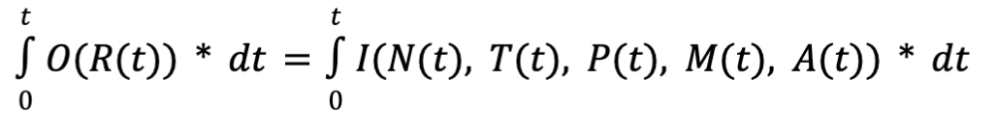
The Theoretical Solving Order - Dependencies
Intuitively, you can’t have a transformation or benefit without a customer set (a benefit relative to who?), you can’t have a price without a transformation or benefit for whom that benefit applies (for what benefit are we charging?), you can’t have a mechanism without a price or a benefit (by what constraints is our engineering team bound and what job does the thing need to do?), you can’t have an access channel without a mechanism, a price, and a customer set since you can’t derive a net contribution before marketing used to determine the bounds of the access channel (how much can we spend to talk to these people, and wait... who are we talking to anyway?).
Consequently, first operators solve for the customer set, 𝑁(𝑡), then the transformation, 𝑇(𝑡), then the price, 𝑃(𝑡), then the mechanism, 𝑀(𝑡), then the access channel, 𝐴(𝑡).
Practically, first you pick a person to help, then you define a fitness benefit and price for that person, then you exploit some sort of technology through a mechanism to deliver the benefit for a cost, 𝑃(𝑡) that is much less than the cost the customer traded to get the benefit,𝑇(𝑡), then you distribute it at scale through 𝐴(𝑡) for a cost such that:
𝑃(𝑡)>> cost to build (inside M) + cost to sell (inside A)
Because all the variables of 𝐼(𝑡) are dependent on 𝑁(𝑡), we can really just say that 𝐼(𝑡) is dependent on the input variables of 𝑁(𝑡), which include the customer set’s size, location, behaviors, capital levels, forces acted on them, genes, and memes imprinted (beliefs), and the ability of operators to apply resources - 𝑂(𝑅(𝑡)), and resources.
In other words, 𝐼(𝑡) is the intersection of the operator's ability to apply resources in an environment (𝑂(𝑡)), the resources and technology available to operators (𝑅(𝑡)), the environment that contains the customer set and the forces that act on that set (𝑁(𝑡)), and time (𝑡).
Defining Productivity And The Optimal State Of I(t), B(t) - Product-Market-Fit State
Now that we have a coordinate system, we can describe what we want to achieve within the coordinate system.
Let’s define the optimal state of 𝐼(𝑡) to be 𝐵(𝑡), and call this the B state - the theoretical most productive state or the product-market-fit state.
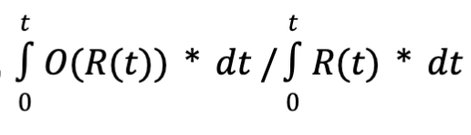
In this state, operators get the highest return in the shortest amount of time within the bounds of their environment and within the bounds of the resources available to them relative to the set on which they are operating and their competitors who operate on a similar set.
Within the “B state”, return, is at a maximum.
In the B state, within the environment and specific to a customer set, 𝑁(𝑡), the benefit, 𝑇(𝑡) addressed is most urgent, marketing costs approach 0 or physical minimum, sales cycle lengths approach 0 or physical minimum, COGs (cost of goods sold) approach the physical minimum that current technology exploited through the mechanism, 𝑀(𝑡) permits, price reaches the theoretical maximum (the price a monopoly would charge if it existed in the market), and cash quickly piles up in a checking account.
When I is in the B state:
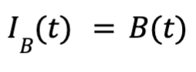
B represents the maximum yield operators can achieve within the bounds of their input resources:
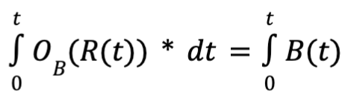
Where 𝑂_{𝐵}(𝑅(𝑡)) is defined to be the operators operating in the B state and 𝐼_{𝐵}(𝑡)to be a business in the B state.
The greater the t delta for which operators operate in the B state, the more durable we say 𝐼(𝑡) is, and the more value is captured by 𝐼(𝑡)’s operators and its shareholders.
The lower the cost/resources, 𝑅(𝑡)required to operate in the B state, the greater the return on capital by 𝐼(𝑡)’s operators and its shareholders.
The shorter amount of time it takes to get to B, the better the return for the shareholders.
Relative “Bness” - To get a high return, operators don't need to exist in B state absolutely, they simply need to be closer to the B state than their competitors relative to a customer segment, 𝑁(𝑡).
Solving For The B State: Defining A Few Problems The Solution Needs To Overcome

Timing Problem
Since the market: N, T, and tech are dynamic, the order in which businesses are built relative to the entire market is significant. Operators need to successfully intersect: tech, awareness, resources, engineering, and time. Poor timing is a result of not building fast enough, building the wrong thing, not having enough awareness, not using the right tech, or not having focus.

Focus and Limited Resources Problem
The solution to 𝐵(𝑡) needs to ensure operators don’t run out of money as they are building and also that the operators stay focused to achieve the B state. Drifting from focus often results in failure. Here’s why:
Solving for multiple B states (starting or running more than one business) or segments simultaneously is really complex:
For example: Solving for 𝐵(𝑡) in two independent environments implies operators are solving a 10 variable problem in a dynamic system instead of a 5 variable problem (which could be much harder than just twice as hard as solving for a 5 variable problem).
For three independent environments, operators are solving a 15 variable problem in a dynamic system instead of a 5 variable problem. The more environments, the less likely operators are to get to a solution to 𝐵(𝑡) for either of the environments. It is therefore very silly to start or operate more than one business at a time, especially when resources are constrained.
The less heterogeneous the customer set on which the operators operate, the more variables are introduced to the problem and the more complex it is to solve.
For example: Consider a 𝑀(𝑡) that satisfies 𝐵(𝑡) for both 𝑁1(𝑡) and 𝑁2(𝑡). 𝑀(𝑡) also needs to satisfy 𝐵(𝑡) with inputs: 𝑇1(𝑡), 𝑇2(𝑡), 𝑃1(𝑡), 𝑃2(𝑡) 𝐴1(𝑡), 𝐴2(𝑡).𝐵(𝑡) is a 9 variable problem instead of 5.
For 𝑁1(𝑡), 𝑁2(𝑡), 𝑁3(𝑡), 𝑀(𝑡) needs to satisfy 𝐵(𝑡) with inputs: 𝑇1(𝑡), 𝑇2(𝑡), 𝑇3(𝑡), 𝑃1(𝑡), 𝑃2(𝑡) 𝑃3(𝑡), 𝐴1(𝑡), 𝐴2(𝑡), 𝐴3(𝑡). This is a 13 variable problem instead of a 5.
Addressing multiple segments with a single mechanism before solving 𝐵(𝑡) relative to a single segment, 𝑁(𝑡) is also silly or very hard.

Speed - Moving Target Problem
Since 𝐵(𝑡) changes with time, to achieve 𝐵(𝑡)operators need to observe/get awareness and understand the market 𝑁(𝑡), and build 𝑀(𝑡) fast enough so that 𝑀(𝑡) is still the solution to 𝐵(𝑡) by the time 𝑀(𝑡) is built - 𝑀(𝑡) is a moving target.
The rate at which operators get awareness, understand a market, and build determines the odds of their business satisfying the B state and capturing any value.
If the rate of change 𝑁(𝑡) or 𝑇(𝑡) is greater than the rate operators can adapt 𝑀(𝑡), 𝐵(𝑡) will not be satisfied and capital will not be efficiently used.

The Solution
The solution to 𝐵(𝑡) is a dynamic sales letter, 𝑆𝐿(𝑡) assembled by operators using a dynamic resource-efficient process, 𝐴𝑠𝑠𝑒𝑚𝑏𝑙𝑦(𝑡) that exploits a technology/ies, 𝑡𝑒𝑐h𝑛𝑜𝑙𝑜𝑔𝑦(𝑡).
Operators input capital, calories, time, and technology. They use an assembly process and output more capital.

Inputs | Outputs
Capital | Capital
Calories
Time
Technology
Assembly Process

Dynamic Sales Letter, SL(t)
The dynamic sales letter is a single dynamic document that defines and discriminates for the market segment, 𝑁(𝑡), proposes the benefit/s, 𝑇(𝑡), and the price 𝑃(𝑡).
It defines the protocol for which the mechanism/product/offer, 𝑀(𝑡) is designed. The protocol is a more efficient method to get to benefit, 𝑇(𝑡) than what already exists relative to the market segment, 𝑁(𝑡).

The sales letter is or is part of the access channel, 𝐴(𝑡), where the conduit that the market segment, 𝑁(𝑡) learns of the other variables is either the screen or paper on which it is printed*
The method by which it propagates is word of mouth driven by the utility, which is the result of the readers learning of the protocol for which the mechanism is designed*
If it goes viral, the cost to market (cost to generate a lead) approaches zero.
It causes sales, pre-orders, or signups that fund the building and/or maintenance of 𝑀(𝑡) or proves demand on which an investment thesis is built, sets the engineering constraints on the COGs (cost of goods sold of the mechanism), and determines the technology that needs to be invented or recruited to satisfy the benefit, 𝑇(𝑡) for the theoretical minimum cost.
It collapses all additional marketing activities down to only the transposition of a single argument to other modes (examples: websites, YouTube content) and the distribution of those transpositions through other media - the website is the html, css, javascript expression of the sales letter, so website designers just transpose the letter.
Salespeople (if they are required to sell the offer) simply read the sales letter and provide feedback to the author so that the sales letter is updated. They also need to communicate the sales letter effectively to the prospect and utilize closing technicals to achieve the highest sustainable closing rate. In the limit, salespeople will not be needed to complete the transaction.
It's quite possible that in the future, all businesses will converge to a single sales letter accompanied by a single product that is automatically assembled by someone or something other than the operators who designed it (Eric Shmit eluded to this technology in an interview where he stated something along the lines of AI inventing new tech at a rate not even possible by humans).
The product and operations team expand and contract based on the lead flow and customer flow created by the resonance and success of the sales letter. This creates a “just-in-time” effect on product and operations.
The sales letter changes with time to meet the market 𝑁(𝑡) - which can be thought of chasing the market around until the benefit, 𝑇(𝑡) “bluntens” or the return on capital forces the business to expand further. At this point, 𝑃(𝑡) and 𝑀(𝑡) no longer satisfy 𝐵(𝑡). At this point, 𝑇(𝑡) is updated, along with the other variables to achieve 𝐵(𝑡).
As sales letters approach B state, cash is accumulating, operators need to expand operations to achieve a reasonable return on capital accumulated, which means they need to change the sales letter.
At this point, operators don’t have a choice but to either address additional N vectors, which requires mechanisms to expand in complexity and robustness to meet multiple B states and preserve returns, or address another segment completely using learnings and capital gleaned from achieving the prior B state/s through a sales letter update.
Examples:
Btc whitepaper -> other crypto protocols
or
The Google Thesis
Dynamic Capital-Efficient Assembly Process
Theoretically, gaining awareness of market and technology, synthesizing insights, and applying those insights to create a dynamic sales letter and accompanying mechanism by exploiting a technology can be infinitely complex and expensive.
If we assume there is a set of tasks required to properly assemble a sales letter, we can assume there is an optimal order in which those tasks are executed, and optimal methods by which those tasks are executed (framework).
When resources are finite and the operators are in a race against competitors, the assembly process needs to be productive, fast, and efficient or “good enough” to get close to the B state or at least closer to the B state than competitors. It also needs to achieve capital efficiency and this efficiency is determined by the amount of capital operators can access.
Furthermore, methods to gather awareness and build things are constantly changing, so the assembly process too is dynamic. It needs to account for the speed, moving target problem.

The variables can be solved by using a loop.
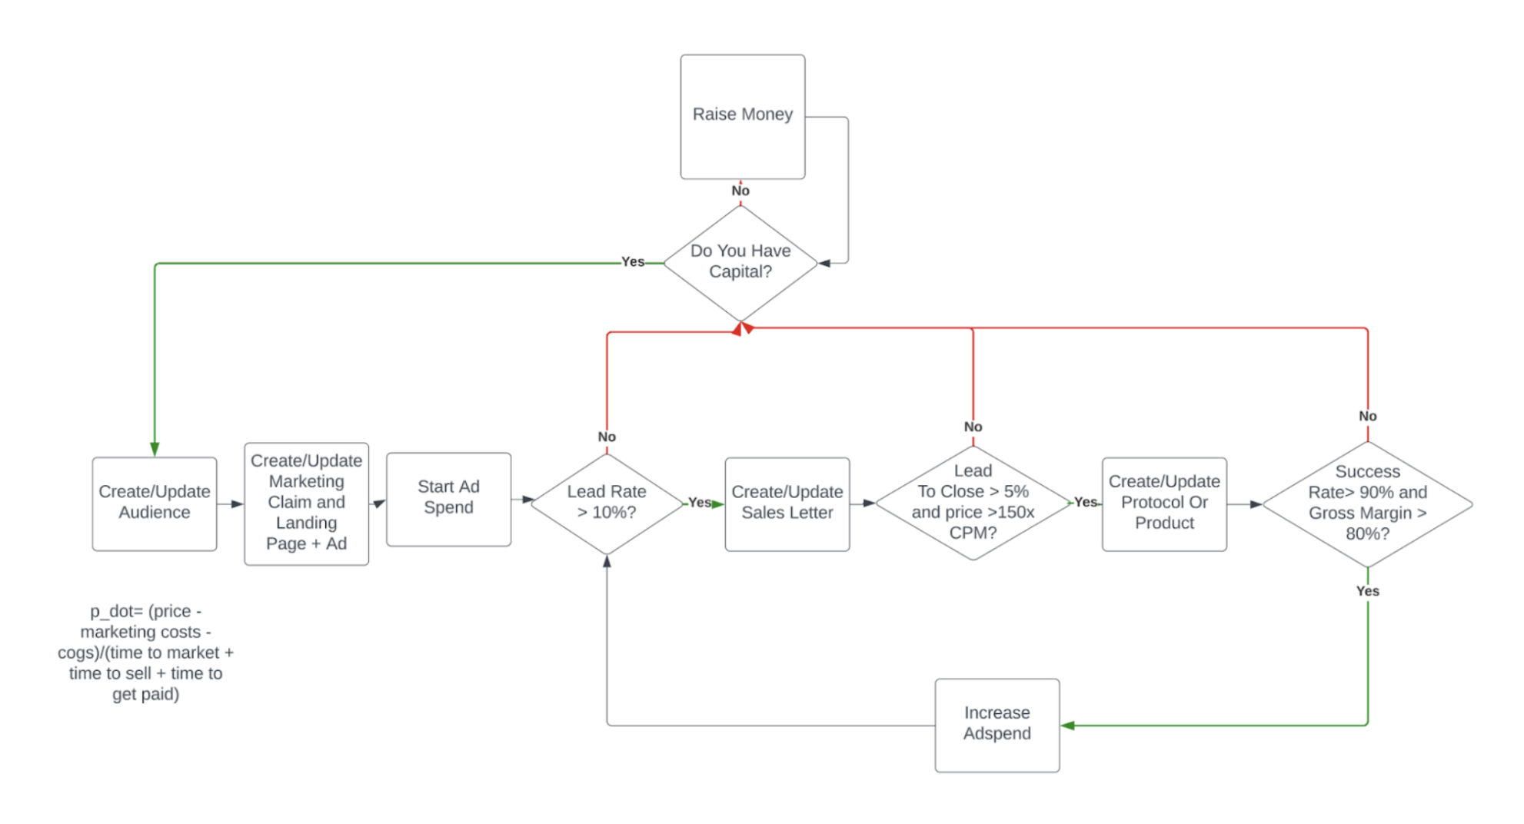

Constraint-Driven Dynamics of I(t)
The Dynamic Sales Letter defines the coordinate system for value creation. It specifies what variables must be solved for and how they relate at a point in time.
Practically it helps us build useful things and channel demand efficiently.
However, if the goal is to maximize productivity over time, a coordinate system alone is insufficient once a business creates surplus.
Businesses are not static mappings from inputs to outputs; they are accumulative systems whose past actions change their future operating conditions.
The moment anything accumulates, the system must decide whether that potential is released, stored, or reinvested. These allocation and timing decisions cannot be derived from the coordinate system itself. They require a higher-order mechanism that governs allocation and timing under constraint.
In accumulative systems, outputs feed back into future inputs by altering the system’s internal state, causing productivity to become nonlinear and path-dependent. This is why linear funnel models and static descriptions collapse over time.
To reason about productivity under these conditions, a control system is required. This system does not redefine value; it governs how accumulated potential is released, retained, or redirected within the direction defined by the Dynamic Sales Letter.
We call this control system the Dynamic Fulcrum. The Dynamic Fulcrum sits on top of the DSL coordinate system and governs allocation decisions that give rise to flywheels, compounding advantage, network effects and self-funding growth dynamics that cannot be modeled by linear iteration alone.

Constraint-Derived State Variables
Sustained Attention Access
Sustained Attention Access is the system’s established accessibility within a niche’s perceptual and cognitive space, reflected in the retained likelihood of encounter and recall. It evolves over time within a given niche-channel context through exposure, reinforcement, and decay, and constitutes a latent readiness for activation under relevant cues. Rather than just accumulating additively, attention access is also positional: once established, its value derives from the ability to access cognitive space. As such, it represents whether interaction with the system is even perceptually available to a given configuration.
Brand memory / identity: The stable semantic “slot” you occupy in the audience’s head. This is the long-lived compounding asset behind Trust.
Trust
Trust is the system’s accumulated credibility within a specific niche, reflected in a retained expectation that its behavior will remain within perceived acceptable bounds under uncertainty. I.e the conversion efficiency multiplier on your distribution. It’s the thing that launches consume and can also replenish. It evolves over time through reinforcement, signaling, and violation, and represents a latent belief state that conditions willingness to engage, independent of any particular interaction.
Raw Transformation Capability
Capability is the system’s accumulated internal capacity to perform classes of transformations with bounded reliability, as embodied in competence, operational knowledge, and the effective use of mechanisms, processes, and coordination. It evolves through learning, decision-relevant computation, configuration, and decay, and represents a latent feasibility frontier independent of whether or where it is currently expressed.

Capability to Access Attention

Capability to enter the niche’s perceptual field

Capability to change the belief of the niche (trust).
Surplus
Surplus is the system’s accumulated retained output, preserved as fungible resources available for redeployment, buffering against uncertainty, or extraction. It evolves over time through retention and dissipation, summarizes the net effects of past realization, and constitutes the system’s only fully transferable state across niches, configurations, and contexts, independent of how or where it is next applied.
Businesses accumulate potential exactly insofar as they accumulate state: Increased probability of encountering a niche and durable presence in their awareness (attention), increased willingness to transact under uncertainty (trust), expanded internal feasibility for performing transformations (capability), and retained output available for redeployment (surplus).
As these state variables evolve through accumulation and decay, the system’s effective production capability (its capacity to realize specific configurations) changes accordingly.
Together, these state variables summarize the retained effects of past actions that condition future configurations; they evolve through accumulation and decay and jointly determine the system’s effective production capability when expressed through a specific N,T,P,M,AN,T,P,M,AN,T,P,M,A configuration.
At this point it is important to distinguish between what the system stores and how its capacity for future work is described. Attention, trust, capability, and surplus are the quantities that actually persist and accumulate over time; they are stored at nodes and constitute the system’s state. When these state variables change, the system’s capacity to produce future output changes as well. To reason about this capacity independent of specific implementations, we introduce an abstract measure analogous to energy in physics. This measure does not exist independently of state and is not accumulated as a substance. Rather, it is a descriptive property of the system’s current configuration, evaluated as a function of its accumulated state.

The moment any of these quantities accumulate, the system must decide whether that potential is released, stored, or reinvested. These allocation and timing decisions cannot be derived from the coordinate system itself. They require a higher-order mechanism that governs allocation and timing under constraint.
To reason about productivity under these conditions, a control system is required. This system does not redefine value; it governs how accumulated potential is released, retained, or redirected within the constraints defined by the Dynamic Sales Letter.
We call this control system the Dynamic Fulcrum. The Dynamic Fulcrum sits on top of the DSL coordinate system and governs allocation decisions that give rise to flywheels, compounding advantage, network effects and self-funding growth dynamics that cannot be modeled by linear iteration alone.
In accumulative systems, outputs feed back into future inputs by altering the system’s internal state, causing productivity to become nonlinear and path-dependent. This is why linear funnel models and static descriptions collapse over time.
The state variables governed by the Dynamic Fulcrum are therefore not selected heuristically, but derived from first principles by enumerating the minimal conditions required for a system to generate surplus through repeated exchange: the system must be encountered by potential exchange partners (attention), induce action under uncertainty (trust), reliably perform the promised transformation (capability), and retain output for reinvestment (surplus). No variable can be removed without collapsing the system’s ability to compound, and no additional variable adds explanatory power.

Any system that produces sustained output over time must obey the same fundamental constraints observed in physical systems. In physics, productive systems are analyzed in terms of energy accumulation, energy release, and energy dissipation. These are irreducible properties of systems that perform work across time.
A business, when stripped of implementation details, is such a system. It converts human attention, coordination, and resources into economic work under competition and uncertainty. To reason about this process independent of specific tactics, we require an abstract quantity that represents stored capacity to perform future work. In physics, this abstraction is called energy. In business, it manifests as attention, trust, capability, and surplus.
The solution for Capital Efficiency is to create a dynamic fulcrum. Since without a fulcrum, a lever is just a rigid object. It loses its ability to multiply force, change direction, or even
function as a simple machine.

The Dynamic Fulcrum Mechanism (DFM) applies energy sciences to structure activities based
on their role in:

Building Up Potential Energy (Production Capability)
A business cannot release value it does not already contain in latent form. Before any exchange can occur, the system must accumulate the ability to define a transformation, deliver it reliably, and signal it credibly. This accumulated ability persists across time and conditions future outputs.
In physics, potential energy represents a system’s capacity to perform future work due to its configuration rather than its motion. Importantly, potential energy is not a stored substance; it is a scalar property of a system evaluated from its current state.
In this framework, Production Capability serves this role. Production Capability is not an independently accumulating quantity. It is the system’s effective capacity to perform future economic work, evaluated as a function of its accumulated state (attention, trust, capability, and surplus) under current environmental constraints. As these state variables accumulate or decay, the system’s production capability changes accordingly. In this sense, production capability increases only indirectly, through improvements in the underlying state that expands the system’s feasible transformation frontier.

A system with high potential energy can produce significant output later, even while inactive.
- So we can project potential (expressed in money) better, if we do work and get returns later
Objective
Build potential energy by increasing the system’s stored capacity to generate future value under finite operator attention and resources.
Inputs
- Capital
- Human judgment and skill
- Technology and tooling
- Market insight and learning
Outputs
- Increased production capability
- Clearer, more reliable transformations
- Greater readiness for efficient distribution
Interpretation
Production Capability determines what is possible. It does not produce immediate output, but it raises the ceiling on what the system can later realize. In energy terms, it charges the system.
Production Capability does not produce immediate output. Instead, it determines what is possible for the system to realize later. Without sufficient potential energy, no amount of execution or distribution can produce sustained output. A system with low production capability must expend disproportionate effort for each unit of value produced.

Distribution Velocity as Kinetic Energy
Stored potential that is never released produces no effect. A system must couple its latent capacity into the environment, propagate signals through attention space, and receive feedback. Time, noise, and competition make this rate critical.
In physics, kinetic energy is energy in motion: stored capacity converted into observable work per unit time.
In business terms, Distribution Velocity governs how quickly accumulated potential is converted into realized transactions, learning, and capital. It determines the rate at which attention propagates, trust converts, and demand materializes into economic output.
Distribution Velocity does not create value on its own. It transforms latent capacity into measurable results per unit time. Faster distribution compresses feedback loops, accelerates learning, and increases the rate at which capital accumulates, enabling further improvements to the system.
Objective
Convert stored potential energy into economic motion by efficiently propagating signals and inducing response.
Inputs
- Accumulated production capability
- Messaging, offers, narratives
- Access channels and conversion mechanisms
Outputs
- Market awareness and engagement
- Transactions and cash inflow
- Fast feedback on system state
Interpretation
Distribution Velocity determines how fast the system learns and earns. It governs signal propagation speed and round-trip response latency. In energy terms, it is the controlled release of stored capacity into motion.

Resource Efficiency as Control of Dissipation
Long-term productivity depends on minimizing loss relative to useful work. Even high production and fast distribution collapse if output dissipates faster than it can be reinvested.
In business, Resource Efficiency plays this role. It governs how much realized output is retained as surplus versus lost to friction, waste, competition, or replication costs. Resource Efficiency determines whether past effort compounds or evaporates. It helps us determine where the best future lives. And it’s what makes time an ally instead of an enemy.
This is where intrinsic value emerges. If a system can repeatedly deliver a transformation at a cost lower than the value created, it generates surplus. When that surplus can be retained and redeployed, the system compounds. When it cannot, growth resets each cycle.
Production Capability defines the upper bound on sustainable throughput, independent of demand.

- Harvest rate: how quickly you extract cashflow from attention/trust
- Regeneration rate: how quickly you rebuild trust/attention through value and delivery
If harvest > regeneration for too long, you’re running an unsustainable strategy (trust depletion).
So your operating rule becomes:
Sustainable creator-business = keep trust regeneration ≥ trust harvest over the cycle, while converting borrowed attention into owned attention.

Objective
Optimize dissipation so that realized output is retained, reinvested, and compounded rather than wasted.
Inputs
- Market feedback and analytics
- Operational and cost data
- Competitive and structural constraints
Outputs
- Retained surplus
- Lower marginal costs
- Increased defensibility and reinvestment capacity
Interpretation
Resource Efficiency determines whether the system compounds. It governs the fraction of output that persists across time and expands future capability. In energy terms, it controls loss and enables accumulation.

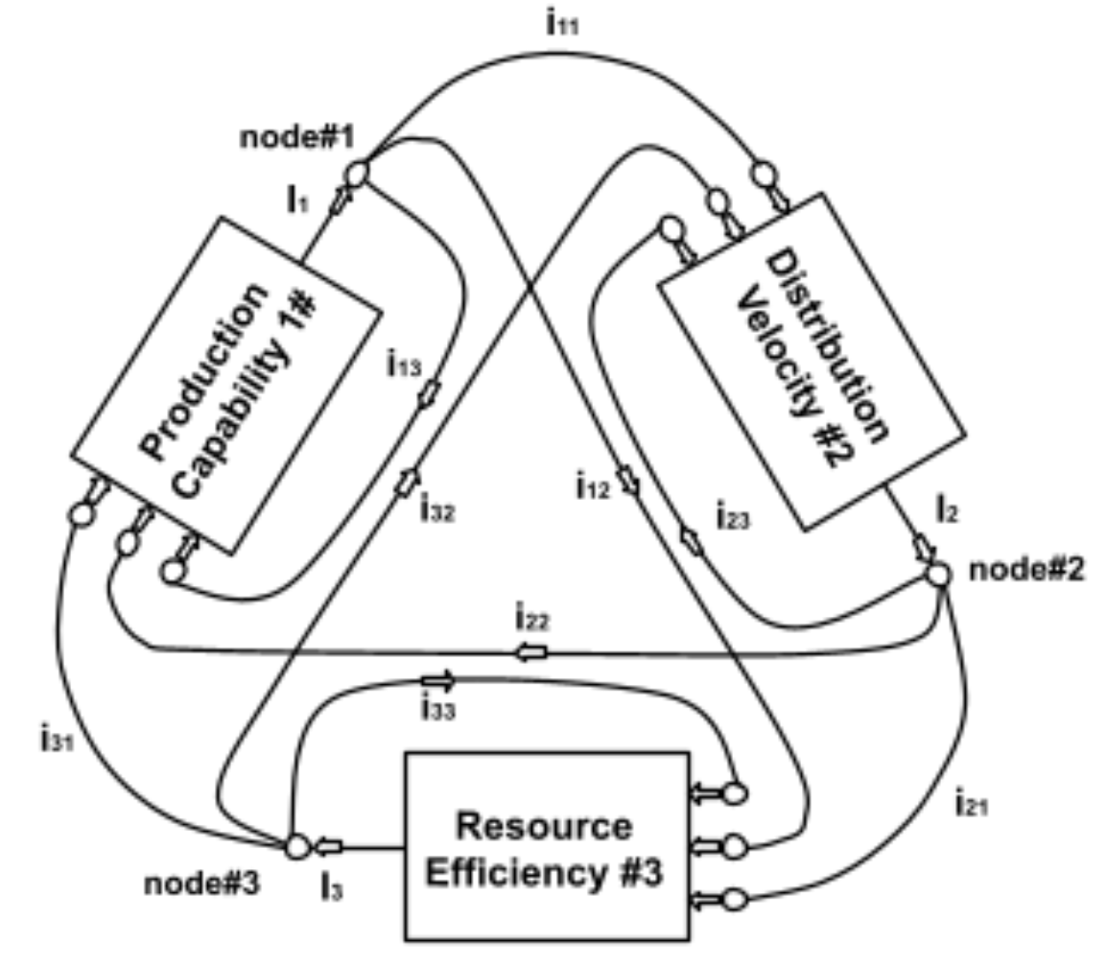
A node is a symbol of flow collection and distribution. Node #3 receives from Resource Efficiency #3 (I3) and (re)distributes to Production Capability #1 (i31), Distribution Velocity #2 (i32). If Resource Efficiency #3 optimizes the flow of function #1 and function #2, then the flow simply indicates that the mechanism is using part of its own output. Meaning the system can become self-funding once it reaches a certain efficiency threshold. Therefore the flow may be summarized by the equations:

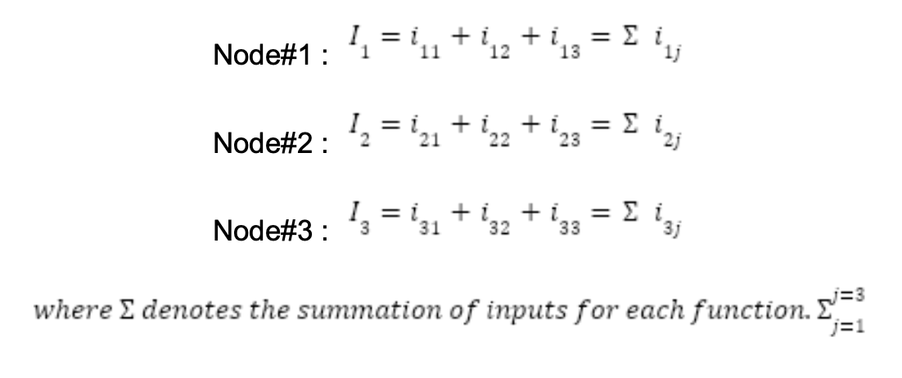
Within this system, nodes represent allocation points where accumulated potential is deliberately released, redirected, or stored. The interconnections between nodes represent information-feedback paths and partially resource flows.

Actuation, Sensing, and State in Accumulative Systems
Production Capability, Distribution Velocity, and Resource Efficiency do not constitute a complete system on their own. They describe how energy is applied, released, and retained, but not how the system determines where or when to act.
In physical and biological systems, action without sensing is blind. Any system embedded in a changing environment must continuously update its internal state based on feedback from reality. Without this feedback, energy is applied against outdated assumptions, increasing dissipation and accelerating failure.
Scenario analysis: accelerating failure. / PMF Collapse

In a business system, sensing does not occur independently of action. The system senses its environment through the responses generated by its own interventions. Signals are emitted into the environment, the environment responds according to its true state, and those responses are internalized as information.
Distribution therefore functions not only as an outward propagation mechanism, but as an active sensing interface. Each act of distribution perturbs the environment and produces a measurable response. The speed, clarity, and cost of this response determine how quickly the system can update its internal model of reality.
Resource Efficiency governs this interface. Its function is not merely to reduce costs, but to regulate how much energy is dissipated per unit of information and capital gained. By minimizing waste, preserving surplus, and retaining feedback, Resource Efficiency ensures that operator judgment remains coupled to environmental truth over time.
Production Capability and Distribution Velocity are actuation functions: they determine how latent potential is built and released. Resource Efficiency is a control function: it determines whether the system’s actions generate usable information or merely dissipate energy.
This interaction can be visualized as a closed-loop system…



A node is a symbol of flow collection and distribution. Node #3 receives from Resource Efficiency #3 (I3) and (re)distributes to Production Capability #1 (i31), Distribution Velocity #2 (i32). If Resource Efficiency #3 optimizes the flow of function #1 and function #2, then the flow simply indicates that the mechanism is using part of its own output. Meaning the system can become self-funding once it reaches a certain efficiency threshold. Therefore the flow may be summarized by the equations:


Within this system, nodes represent allocation points where accumulated potential is deliberately released, redirected, or stored. The interconnections between nodes represent information-feedback paths and partially resource flows.
Nodes represent allocation points where accumulated potential is deliberately released, redirected, or stored. Interconnections represent information-feedback paths, not literal resource flows.
Node #1: investment in production / value creation / product quality
Node #2: investment in distribution / sales / attention
Node #3: surplus allocation / retained earnings / data analytics / operational efficiency
Feedback paths exist to surface constraint information before capital, time, or attention are reallocated. When retained surplus is sufficient, the system can become self-funding.
Each function within the DFM has multiple inputs and one clearly defined output. The system's
inherent stability is ensured through the three interconnected functions, each operating as a
self-contained unit. This modular structure allows for flexibility while also maintaining overall
system integrity.

The Dynamic Sales Letter defines what constitutes value and for whom; capital efficiency emerges from how operators allocate and time resources within those constraints over time.

In this system, “energy” refers not to a physical quantity, but to accumulated optionality: attention that has not yet been monetized, trust that has not yet been converted, capability that has not yet been deployed, and surplus that has not yet been reinvested. These stores of optionality can be preserved, released, or dissipated depending on operator judgment.
The three functions describe distinct allocation roles:
- Production Capability governs the accumulation of latent value by defining and refining transformations that could be exchanged with a niche.
- Distribution Velocity governs the controlled release of that latent value into the market, converting accumulated optionality into transactions and learning.
- Resource Efficiency governs how much of the resulting surplus is retained and how it is redeployed to expand future capability or accelerate future release.
Nodes in the system represent allocation and release decisions rather than activities. At each node, operators choose whether to deploy accumulated potential immediately, store it for later release, or redirect it toward a different function. These decisions determine whether leverage compounds or dissipates.
The system can become self-funding once retained surplus is sufficient to finance future production and distribution without external input. At that point, growth is governed primarily by allocation discipline rather than raw resource availability.
This framing is descriptive rather than predictive. It does not claim numerical precision, but clarifies the structural dependencies that determine whether value creation, propagation, and capture remain aligned over time.

The Dynamic Sales Letter defines a valid coordinate system for value creation, but it is inherently linear. Modern businesses operate as accumulative systems in which attention, trust, capability, and surplus compound over time. In such systems, capital efficiency depends not only on defining correct variables, but on continuously deciding when accumulated potential should be released, retained, or redirected.
For this we require a control system that sits on top of the coordinate system. It governs these allocation and timing decisions. We can call this the Dynamic Fulcrum. It functions as a control system that sits on top of the DSL (coordinate system), enabling flywheels, compounding advantage, and self-funding growth that cannot be explained and modeled by a linear funnel model alone.
The Dynamic Fulcrum can be understood as a feedback-controlled, non-equilibrium system in which accumulated optionality is stored, released, and reinvested through explicit allocation decisions, producing nonlinear growth dynamics.

Resource Efficiency (State Variable #3)
The system’s current ability to retain surplus and redeploy it to increase future capability or velocity rather than dissipating it.

The boxes are functions

The nodes are control points that decide how surplus and effort change the state (they are state variables)
The flows are dependency paths showing how one state constrains another

Production capability, distribution velocity, and resource efficiency function as state variables: they summarize the system’s accumulated capacity, constrain feasible actions, and determine how allocation decisions propagate over time.

In the Dynamic Fulcrum, production capability, distribution velocity, and resource efficiency are treated as state variables that parameterize functional transformations rather than activities. Each function maps inputs to outputs conditioned on the system’s current state, producing a single decision-relevant output at each stage. Potential value is generated as a function of production capability, realized as revenue as a function of distribution velocity, and retained as surplus as a function of resource efficiency. Profit (α) therefore emerges as the composite output of these state-dependent transformations and serves as the primary feedback signal governing future allocation decisions.

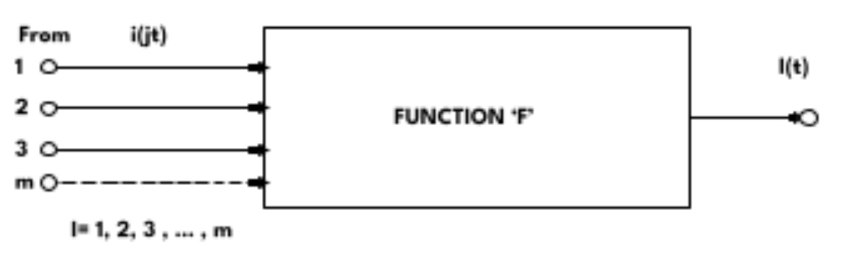

Capability is a state variable that defines the feasible transformation set. Capacity is a derived flow constraint determined by the mechanism and structure through which capability is expressed. Distribution Velocity governs how quickly that capacity is released into the environment and converted into feedback and surplus.

Solving For Maximum Distribution Velocity

Which is the degree to which a system, explanation, or framing is remembered, cued, and invoked without direct contact. Durable attention is therefore memetic rather than purely distributive.
Distribution Velocity is the rate at which a system’s configured potential is realized through interaction with a population, including external propagation through channels and internal activation through recall, cueing, and explanation. It measures how quickly a configuration is encountered, remembered, invoked, and acted upon, whether via direct exposure or endogenous triggering within the host’s cognitive environment. Because internally cued activation does not require fresh expenditure or exposure, distribution velocity may be sustained or increased even as external distribution effort declines. External distribution produces transient exposure, while internal distribution produces self-reinforcing activation. The latter compounds because each realization increases the probability of future realization without proportional increases in effort. Distribution that installs durable cognitive structures differs categorically from distribution that merely generates exposure: the former creates internal activation pathways that compound over time, while the latter resets unless continuously replenished. Distribution velocity is not just how fast something spreads, but how reliably it is re-activated. Systems that live inside the host compound distribution endogenously; systems that rely on exposure must continually pay to exist.

Distribution Velocity behaves like a signal propagation subsystem.
- a source
- a carrier
- a channel
- an antenna
- a receiver
- noise
- attenuation
- bandwidth limits
An antenna converts stored energy into propagating electromagnetic waves
and couples those waves into an environment where receivers may exist.

Translated to business the antenna converts stored value potential (insight, narrative, capability)
into propagating informational signals that can reach and activate a niche
Distribution Velocity functions as a signal propagation system: it converts stored value potential into transmitted informational signals that couple into an attention environment with measurable gain, loss, noise, and latency.

Two primary constraints on Distribution Velocity (decision layer)
To decide Distribution Velocity at time ttt, the system must resolve two orthogonal questions:

1. How much demand can we generate?
(Outbound constraint — environment-facing)
This is bounded by:
- attention reach (owned + accessible)
- channel throughput
- trust / belief update speed
- audience fatigue and noise
In short:
How fast can we perturb the environment and induce response?
This determines the maximum feasible outbound signal rate.

2. How much demand can we absorb?
(Inbound constraint — system-facing)
This is bounded by:
- capacity (projection of capability through mechanism)
- fulfillment reliability
- operational slack
- error tolerance
In short:
How much of that response can the system actually convert into realized value without degradation?
This determines the maximum feasible realization rate.

Core constraint (this is the key equation conceptually)
Anything above either bound produces:
- wasted spend (if demand > capacity)
- idle potential (if capacity > demand)

Second-order control questions (Resource Efficiency layer)
Once the two primary bounds are known, Resource Efficiency governs how to operate near the frontier.
These are not velocity questions; they are control questions:
- What price maximizes retained surplus over time?
- How frequently can we launch without burning trust or attention?
- How much slack do we maintain vs. push utilization?
- When do we trade short-term velocity for learning?
- When do we intentionally slow distribution to preserve signal quality?
These questions determine:
How much energy is dissipated per unit of information and surplus gained.
That is why they belong to Resource Efficiency, not Distribution Velocity.

The New Salesprocess
Rational economics (Rational Trade offs: Time cost, energy cost, capital cost, opportunity cost)
Irrational economics (Irrational desires; unconscious, emotional, etc)

